Requirement Details

1)Create Multiple RITM Creation Logic.js
Logic Written: Flow Action.
Requirement; Create Multiple RITM in one catalog item depending on one of catalog item variable values
Requirement in details- For example, if 4 applications are selected in the Application candidate variable, 4 RITMs will be created, including the existing RITM (when the catalog item is submitted). The new RITMS short description, all variables and one flow will attach.

Note: In logic inputs.script_availableSoftware(Input Values of Application Candidate variable) taken form flow in flow action same for all variables.

Below are catalog item for reference
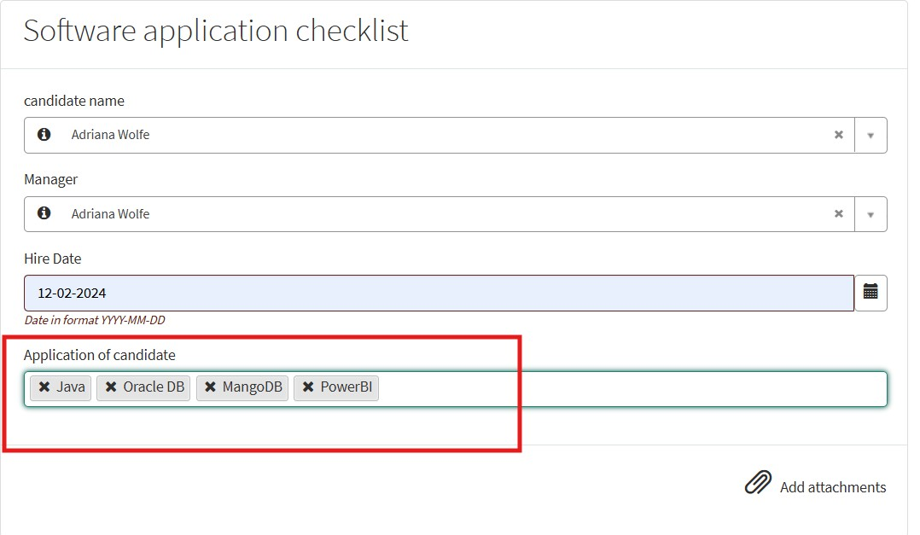

2Manager Chain Logic.js
Logic Written: Business rule
Requirement:In sys_user table has a manager reference field that points to another user.A top-level manager is a user whose manager field is blank.
Logic should traverse the manager chain until reaching the top-level manager.

